NH-is-Blooming Observation Instructions
- Each month we will send you an observation “package” which identifies four or five pollinator friendly flowers that we would like you to watch for anywhere you happen to be around NH.
- When you see one of the flowers, record it on the observation sheet by noting the date, town, and whether you saw pollinators on the flowers.
  - If you see other flowers with pollinators, feel free to also record that on the observation sheet.
- At the end of the month, you can send your observation sheet via either email to nh.is.blooming.com or by USPS mail at: NH-is-Blooming, PO Box 250, Gilmanton, NH 03237.
  - We will add it to the NH-is-blooming database soon after we receive it.
  - We are happy to accept the observations in any format that is easy for you!
- Send questions to: nh.is.blooming@gmail.com

NH-is-Blooming July Observation Flowers
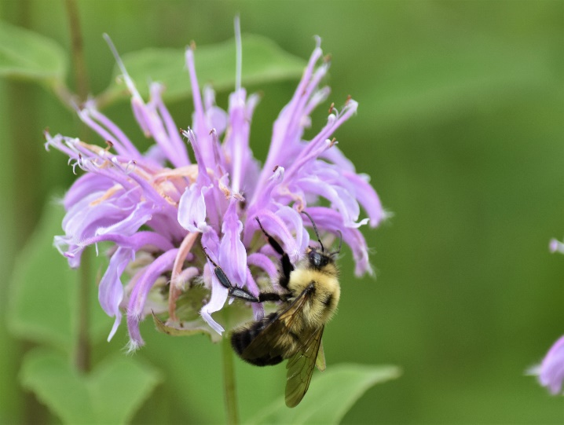
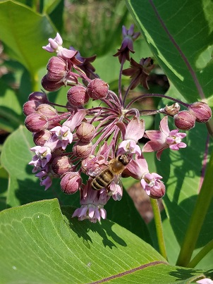

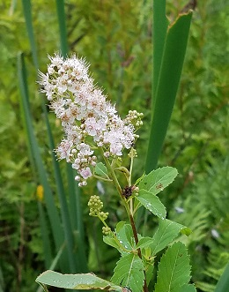
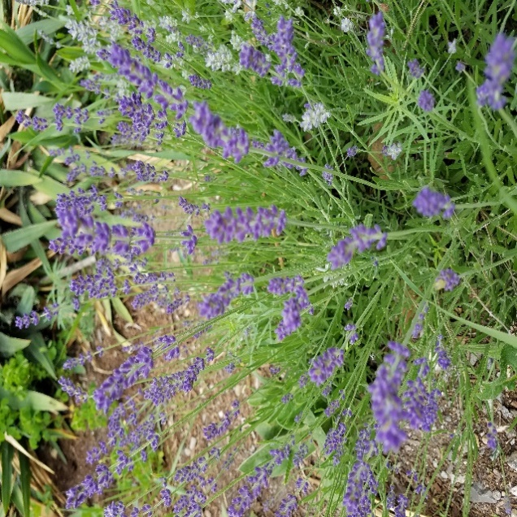
Bee Balm
Description: leafy bracts support solitary, terminal, tubular and narrow. Multiple colors.
Pollinators : nectar source

Source: https://plants.usda.gov/plantguide/pdf/pg_modi.pdf

Lavendar
Description: Diverse leaf shape, flowers are in whorls, held on spikes.
Pollinators : nectar & pollen source

Source : https://en.m.wikipedia.org/wiki/lavendula
Meadowsweet
Description: Delicate, creamy-white flowers, clustered on branched cymes.
Pollinators : pollen & nectar source

Source: https://en.m.wikipedia.org/wiki/Filipendula_ulmaria
Milkweed
Description: solitary, hairy stem, from a rhizome. Small complex flowers, purple tinged.
Pollinators : abundant nectar source

Source: https://plants.usda.gov/plantguide/pdf/cs_assy.pdf

