NH-is-Blooming Observation Instructions
- Each month we will send you an observation “package” which identifies four or five pollinator friendly flowers that we would like you to watch for anywhere you happen to be around NH.
- When you see one of the flowers, record it on the observation sheet by noting the date, town, and whether you saw pollinators on the flowers.
  - If you see other flowers with pollinators, feel free to also record that on the observation sheet.
- At the end of the month, you can send your observation sheet via either email to nh.is.blooming.com or by USPS mail at: NH-is-Blooming, PO Box 250, Gilmanton, NH 03237.
  - We will add it to the NH-is-blooming database soon after we receive it.
  - We are happy to accept the observations in any format that is easy for you!
- Send questions to: nh.is.blooming@gmail.com

NH-is-Blooming May Observation Flowers
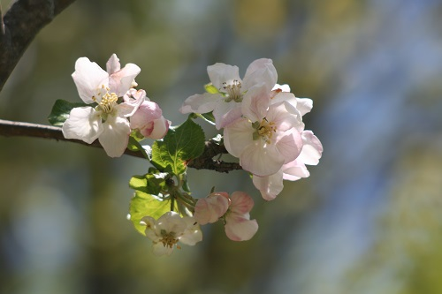
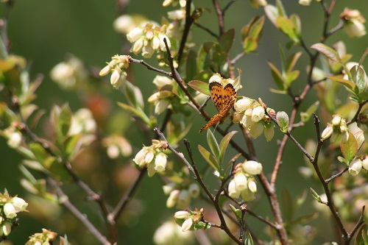

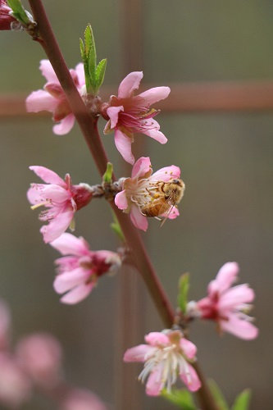
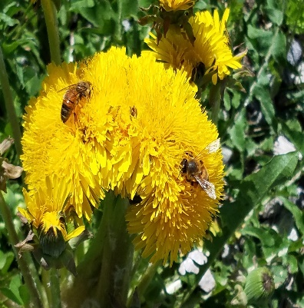
Blueberries
Description: High & low bush varieties
Pollinators : pollen source

Source: https://en.wikipedia.org/wiki/Blueberry

Peach Tree
Description: Fruit tree with pink blossoms
Pollinators : nectar & pollen source

Source : https://en.wikipedia.org/wiki/Peach
Dandelion
Description: Early native wildflower
Pollinators : early pollen & Nectar source

Source: https://www.buzzaboutbees.net/Bees-And-Other-Pollinators-Love-Dandelions.html
Apple Tree
Description: fruit tree typically with white/pinkish blossoms
Pollinators : pollen & nectar source

Source: https://en.wikipedia.org/wiki/Apple

